Daniel J. Gallegos

Teepu Khan

May 11, 2017

Test Cases:

1. Page reference:20; Range:0-7; Physical frames:3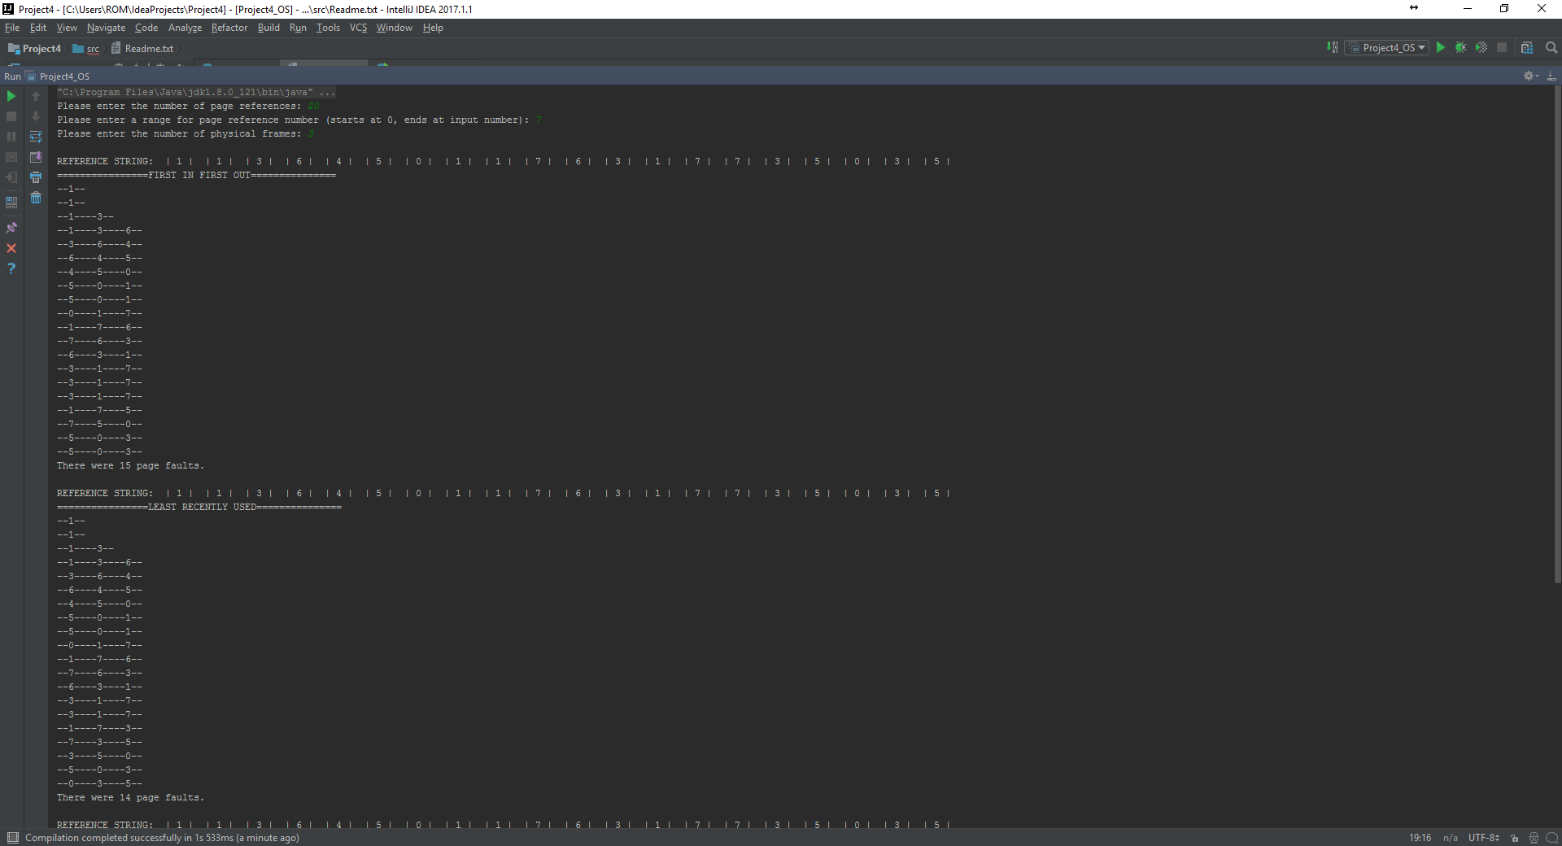

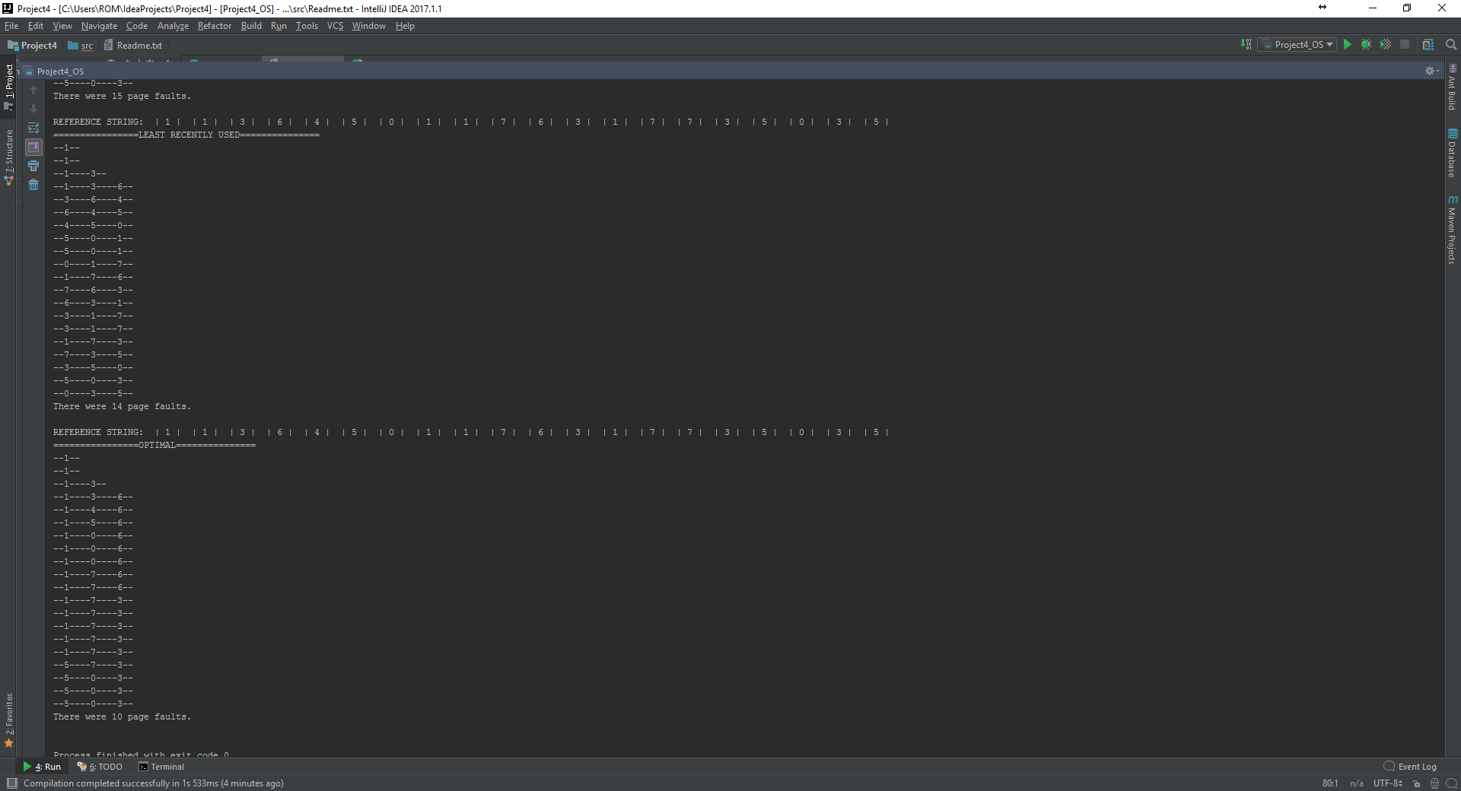

1. Page reference:20; Range:0 -7; Physical frames:6

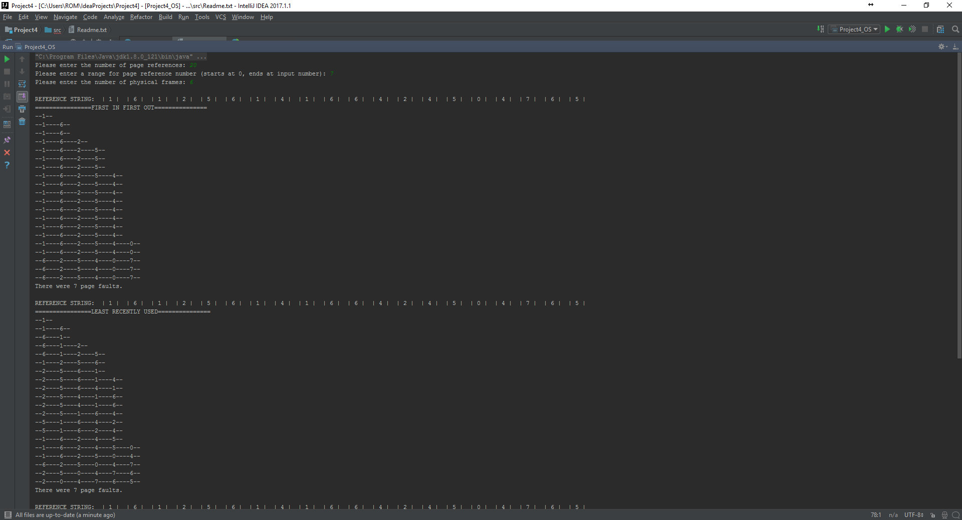

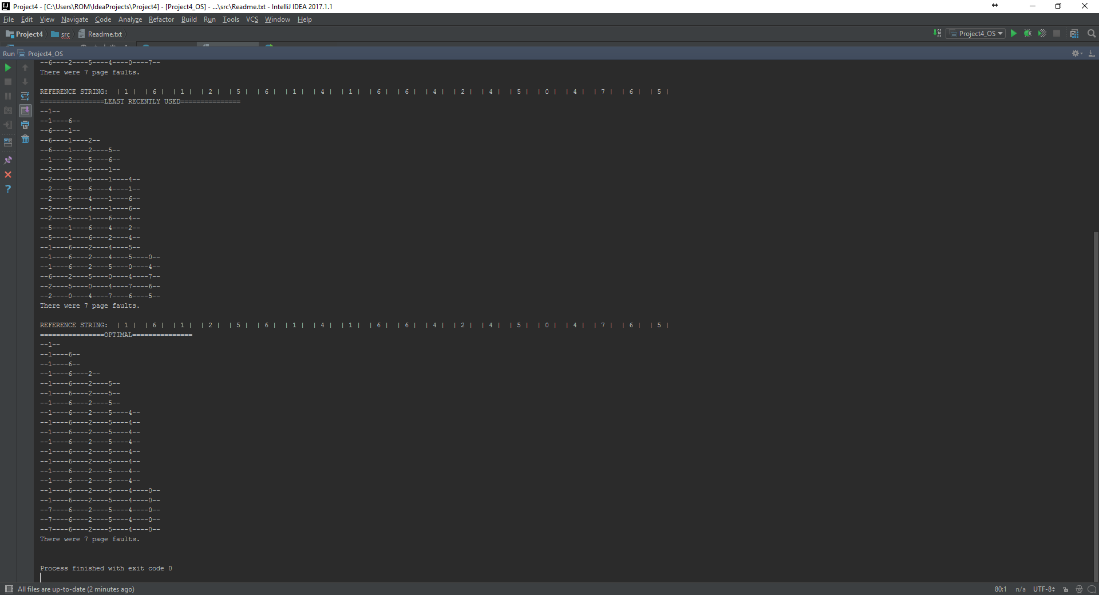

1. Page reference: 20; Range:0 -7; Physical frames:12

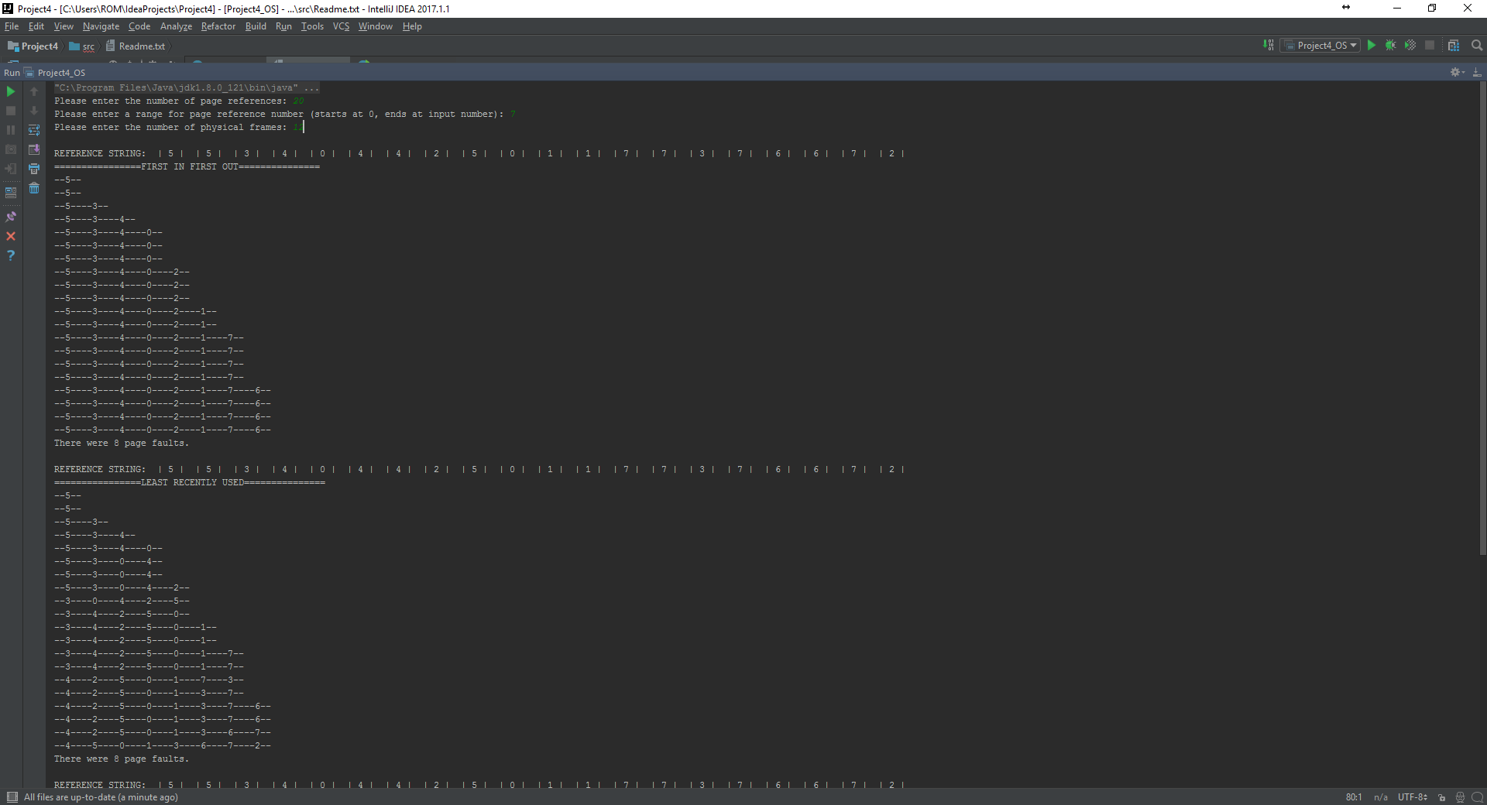

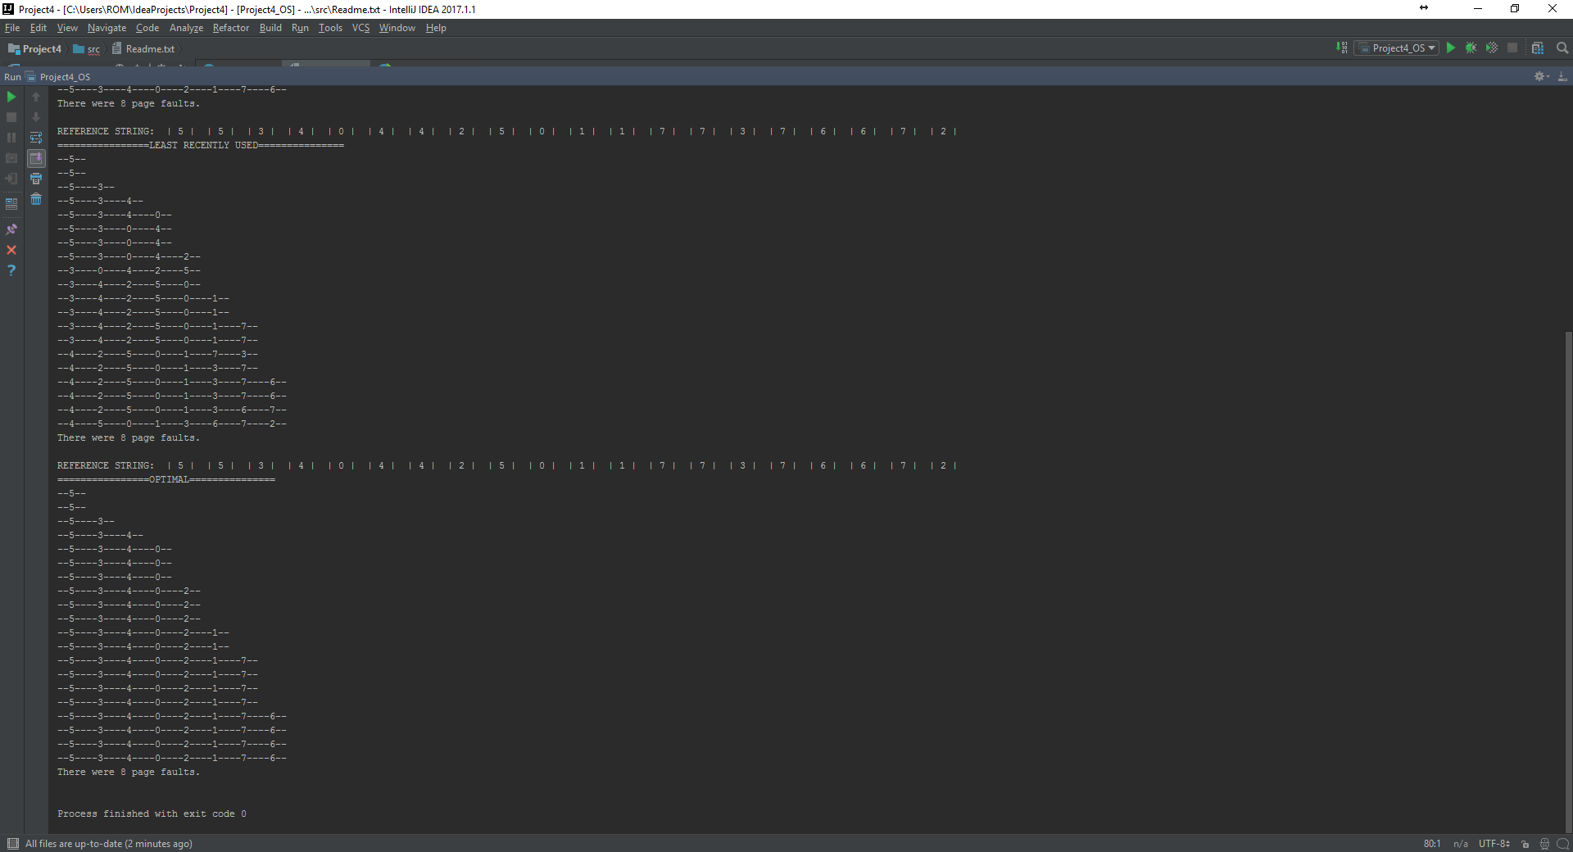

1. Page reference: 20; Range:0-7; Physical frames:16

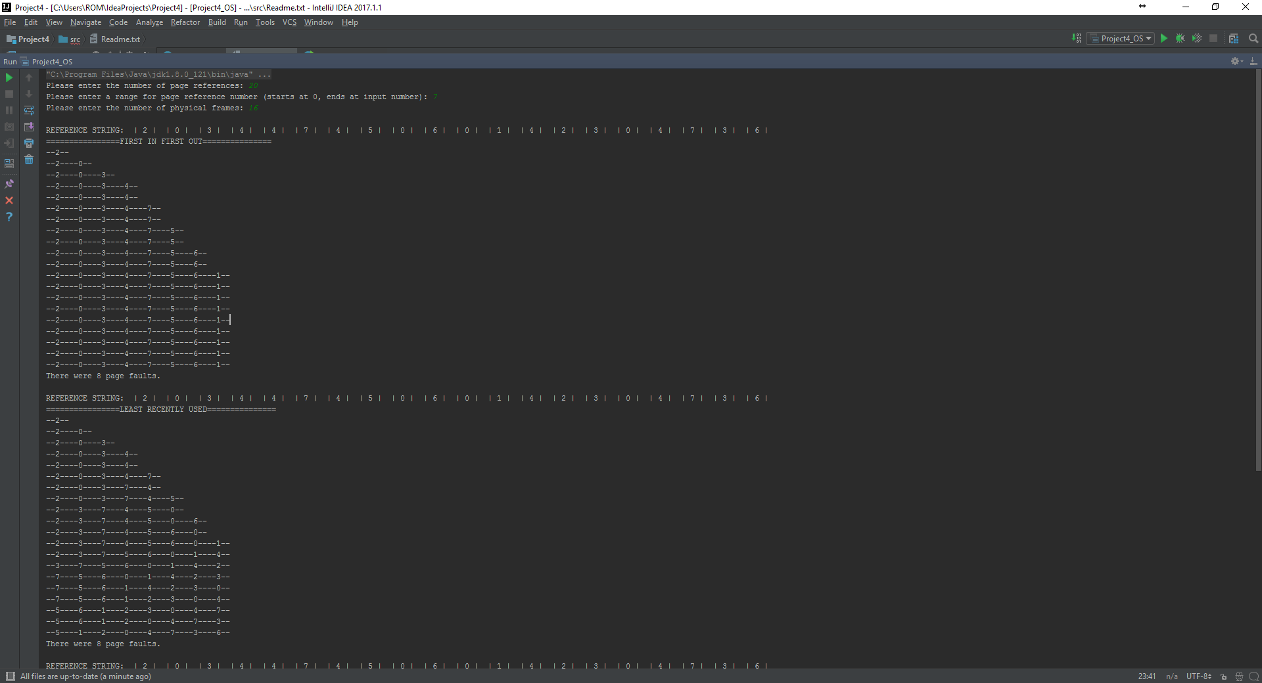

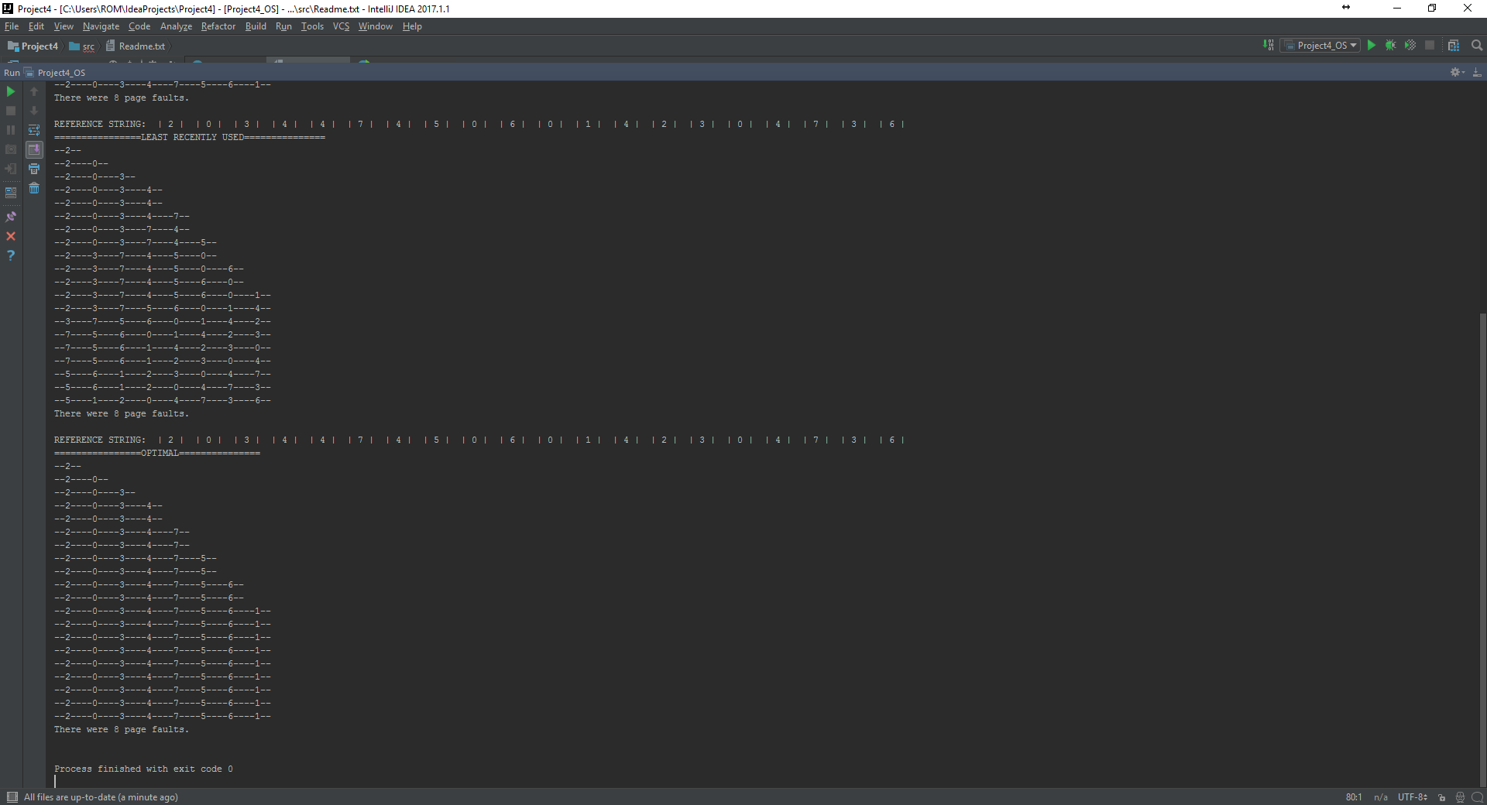

1. Page reference:20; Range:0-7; Physical frames:18

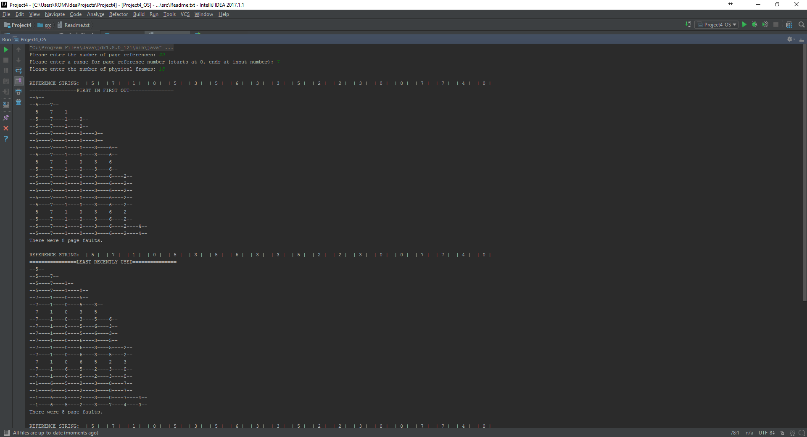

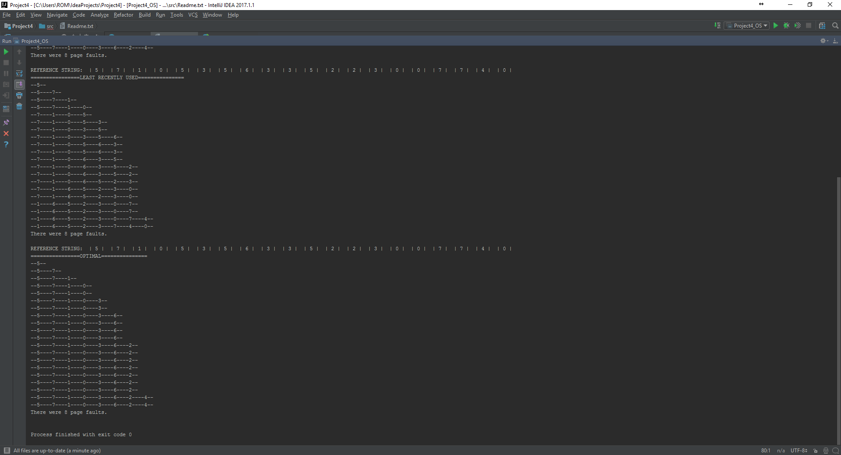

The number of page faults stabilizes at 8 for the case of 20 page references in the range of 0-7.